Final Project Report: Customer Churn Analytics & Predictive Modeling
Organization: Australian Computer Society (ACS) Project Focus: $2.86M Revenue Leakage Mitigation

Summary of Key Findings
The integration of K-Means clustering and an Artificial Neural Network (ANN) has enabled the identification of a significant revenue recovery opportunity valued at approximately $2.86M. The analysis revealed a critical behavioural pattern known as the “onboarding cliff” at around 9.8 months, were customer attrition peaks sharply. This indicates that early-stage customers are the most vulnerable and require immediate engagement strategies.
By achieving an ANN model accuracy of 79.6%, the project successfully shifted from traditional historical analysis to predictive foresight, allowing the organisation to proactively identify high-risk customers before churn occurs. Overall, the findings highlight that while most customers are retained, a substantial proportion still leave, creating a measurable and preventable revenue leakage.
Further insights from customer segmentation and feature analysis show that churn is primarily driven by factors such as tenure and monthly charges, with short-tenure and high-cost customers being the most at risk. The clustering model identified key personas, particularly “At-Risk Newbies,” who exhibit the highest churn rates and contribute significantly to revenue loss during the early lifecycle stage. Additionally, a high-risk micro-segment—senior customers using fiber services—was found to have disproportionately high churn rates, suggesting issues related to pricing, service complexity, or support. T
hese findings, supported by the ANN model’s predictive capability, establish a clear connection between customer behaviour, pricing structures, and churn risk, providing a strong foundation for targeted retention strategies aimed at reducing churn and recovering lost revenue.

Understanding the Dataset

Raw Dataset Preview (Top 5 Rows)
This image provides a snapshot of the dataset by displaying the first five rows, giving an overview of the available features such as customer demographics, service details, contract type, monthly charges, and churn status. It helps in understanding the structure and types of data being used for analysis, including both categorical and numerical variables.
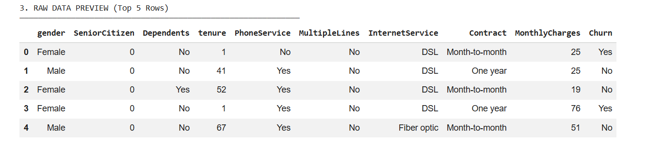
Figure 1 Raw Dataset Preview
The preview highlights key attributes like tenure, internet service type, and contract type, which are important for identifying churn patterns. Overall, this step ensures familiarity with the dataset before further processing and modelling.

Dataset Structure Overview
This image presents a structured overview of the dataset used for customer churn analysis, including each variable’s data type, number of missing values, unique values, and a sample entry. It shows that the dataset is clean, with no missing values across all features, ensuring reliability for modelling.
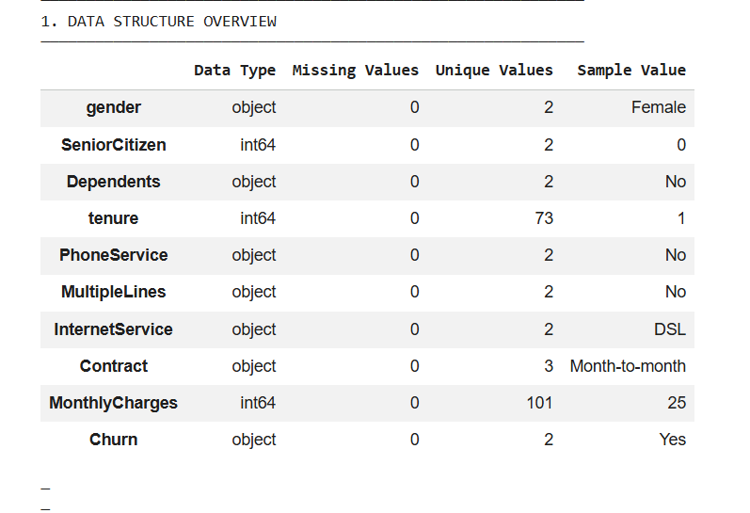
Figure 2 Data Structure
Key variables such as Contract, InternetService, and MonthlyCharges provide important business insights, while Tenure and Churn serve as critical variables for predicting customer behaviour. The mix of categorical and numerical features highlights the need for preprocessing before applying models like ANN. Overall, the table confirms that the dataset is well-prepared and suitable for both clustering and predictive modelling tasks.

Data Preparation & Encoding Summary
This image shows the data preparation phase, confirming that there are no missing values across all variables and that encoding has been successfully completed, resulting in a final dataset of 7,043 records and 11 features. While this indicates a clean and well-prepared dataset, it also highlights a limitation—real-world data is rarely perfect.
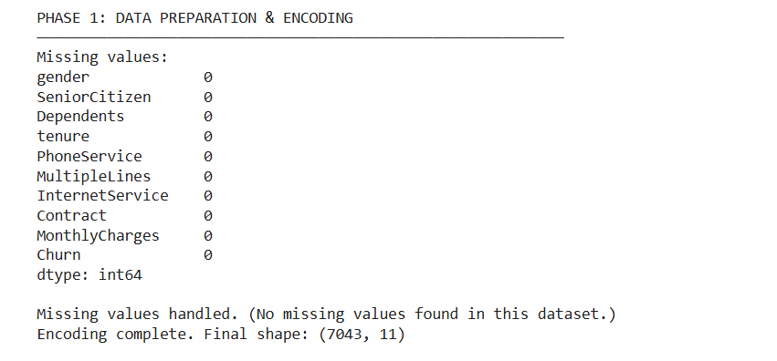
Figure 18 Data Preparation and Encoding
The absence of missing values suggests the dataset may not fully capture real-world complexities, potentially reducing the model’s ability to generalise. This reinforces the need for future improvements such as incorporating more diverse data sources and handling real-world data inconsistencies.

Churn Overview (Problem Definition)

Customer Churn Distribution
This image shows the overall distribution of customers who stayed versus those who churned. The majority of customers (around 5000+) did not churn (0), while a smaller portion (around 1800–2000) did churn (1). This indicates that although most customers are retained, there is still a significant number of customers leaving the service.
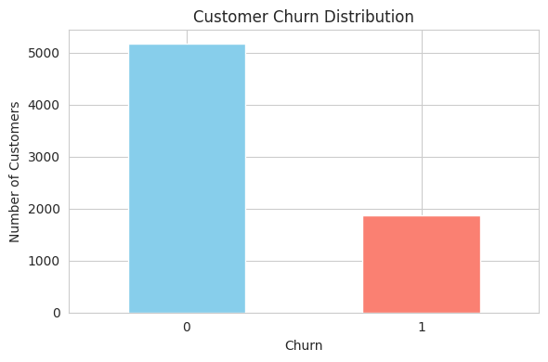
Figure 8 Customer Churn Distribution
The imbalance in the data also highlights a class imbalance issue, where non-churn cases dominate, which can affect the performance of predictive models like ANN. Overall, the chart provides a clear snapshot of the churn situation and the scale of the problem.

Churn Market Share Distribution
This image shows the overall distribution of churn within the dataset, indicating that 73.46% of customers are retained while 26.54% have churned. This highlights that although the majority of customers stay, a significant portion still leaves, representing a notable business concern.
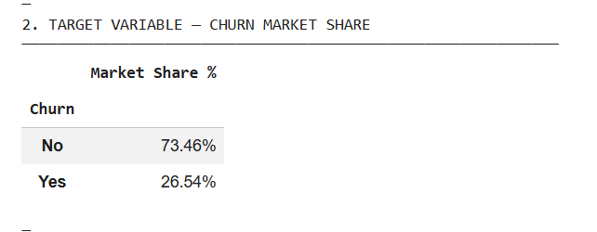
Figure 4 Churn Market Share Distribution
The distribution also reveals a class imbalance in the dataset, where non-churn cases dominate, which can influence model performance. Overall, this provides a clear baseline understanding of the churn landscape and the scale of customer attrition.

Customer Segmentation (Who is at Risk)

Customer Segmentation Scatter Plot (Personas Mapping)
This image visualises customer segmentation based on tenure and monthly charges, grouping customers into three personas: At-Risk Newbies, Loyal High-Rollers, and Stable Budgeteers. The At-Risk Newbies cluster is concentrated at low tenure with moderate charges, indicating early-stage customers who are more likely to churn. Loyal High-Rollers are spread across higher tenure and higher monthly charges, representing high-value customers with strong revenue contribution.
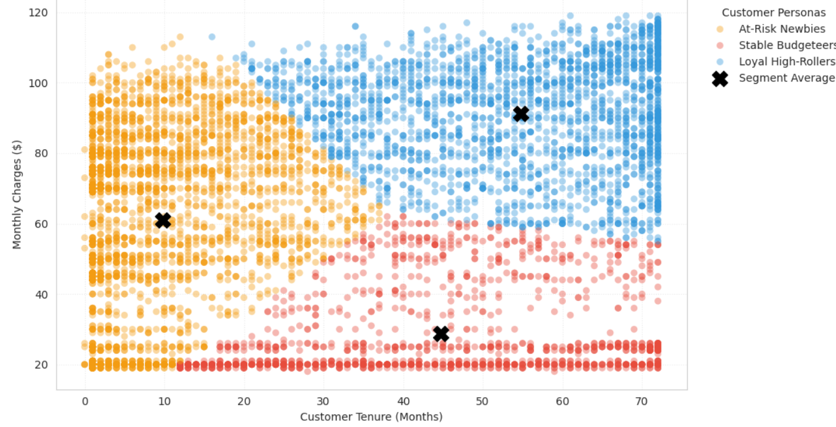
Figure 5 Customer Segmentation Scatter Plot (Personas Mapping)
Stable Budgeteers fall into lower charge ranges with moderate to high tenure, showing consistent but lower-value behaviour. The marked averages highlight the central tendencies of each segment. Overall, this visualization clearly demonstrates distinct customer groups and supports targeted retention strategies.

Customer Segmentation Persona Audit
This image presents the results of customer segmentation using clustering, grouping customers into three distinct personas based on tenure, spending, and churn behaviour. The At-Risk Newbies segment has the highest churn rate (42.54%) with low tenure (~9.8 months), highlighting the critical onboarding risk period. The Loyal High-Rollers generate the highest revenue but still show moderate churn (18.48%), making them valuable but vulnerable customers.
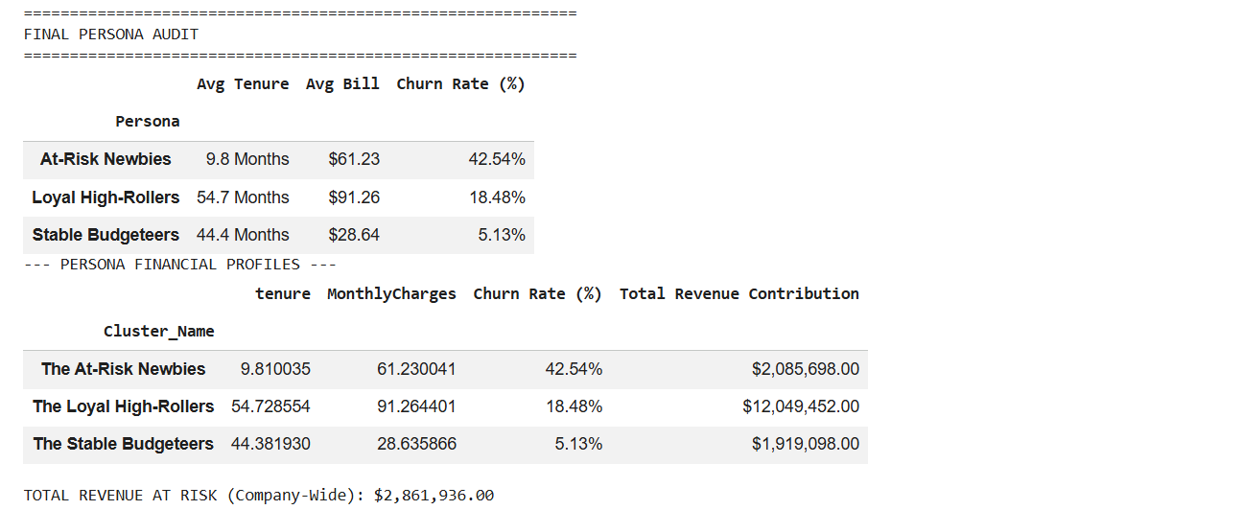
Figure 9 Final Persona Audit
The Stable Budgeteers have low churn (5.13%) and lower spending, representing a stable but less profitable group. The financial analysis further shows that the At-Risk Newbies alone contribute over $2M in revenue at risk, leading to a total company-wide revenue leakage of approximately $2.86M. This segmentation clearly identifies which customer groups require immediate attention and targeted retention strategies.

Key Business Insights

Customer Churn by Tenure (Onboarding Cliff Analysis)
This image illustrates customer churn behaviour across different tenure periods, highlighting a critical drop-off point around the 10-month mark, referred to as the “onboarding cliff.” The chart shows that a large number of customers leave within the early months of their subscription, with churn volume significantly higher before reaching 10 months.
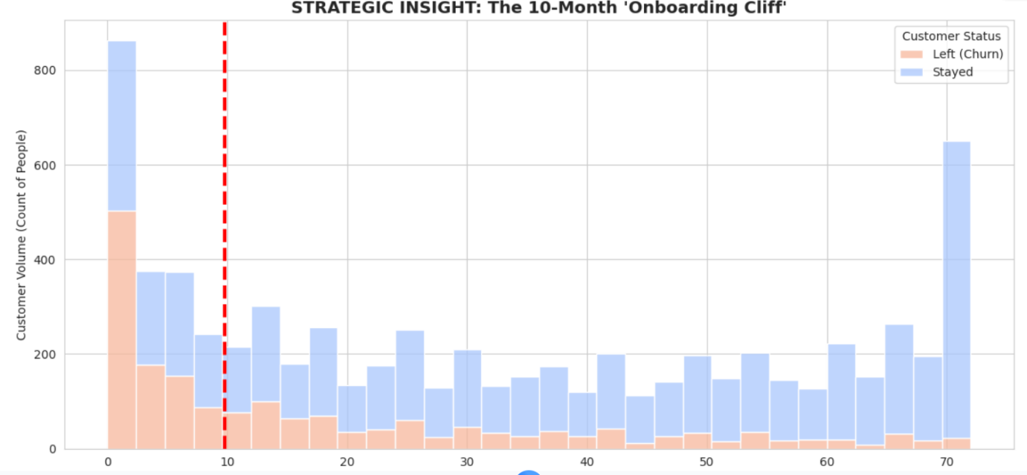
Figure 6 Customer Churn by Tenure (Onboarding Cliff Analysis)
After this point, customer retention improves, as indicated by the increasing number of customers who stay. This pattern reveals that early-stage customers are the most vulnerable, emphasizing the importance of engagement and retention strategies during the initial months of the customer lifecycle.

Revenue Impact by Customer Segment (Active vs Lost Revenue)
This image compares total revenue generated and revenue lost due to churn across different customer segments. It shows that Loyal High-Rollers contribute the highest overall revenue (over $10M) but also experience significant revenue loss (~$1.97M), making them both highly valuable and at risk. The At-Risk Newbies segment shows a notable proportion of revenue loss relative to its total contribution, reinforcing their vulnerability during early stages.
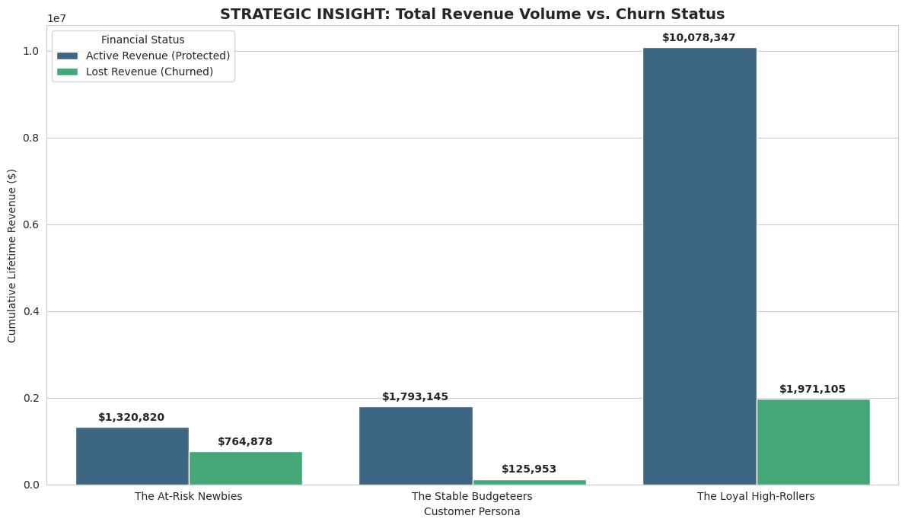
Figure 7 Revenue Impact by Customer Segment
In contrast, Stable Budgeteers generate moderate revenue with minimal losses, indicating stability. Overall, the chart highlights how churn impacts revenue across segments and identifies where the greatest financial risks lie.

Revenue Leak Risk Heatmap (Fiber-Monthly Danger Zone)
This image presents a heatmap showing churn probability across different combinations of service type and contract commitment. It highlights that customers using standard/DSL or fiber services on high-risk month-to-month contracts exhibit the highest churn rates, with values reaching up to 28.7%.
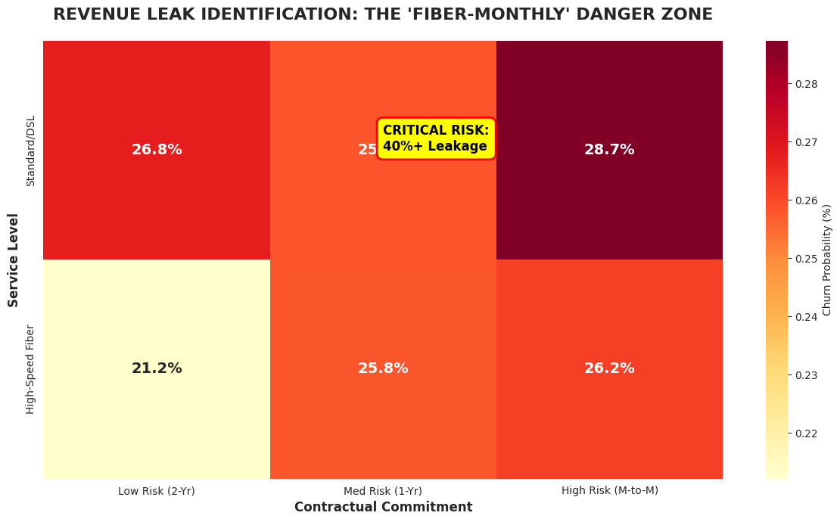
Figure 15 Revenue Leak Risk Heatmap
The visualization identifies a critical risk zone where low contractual commitment and certain service types significantly increase the likelihood of churn. This indicates that contract type and service level are key factors influencing customer retention, contributing directly to revenue leakage. Overall, the heatmap helps pinpoint high-risk segments that drive churn behaviour.

Feature Engineering (How Model Was Strengthened)

Feature Engineering & Business Aware Variables
This image presents the feature engineering phase, where new business-aware variables were created to improve the predictive power of the model. Features such as CustomerValue (tenure × MonthlyCharges), TotalServices, Senior_Fiber_Risk, and ContractRisk were introduced to better capture customer behaviour and risk patterns.
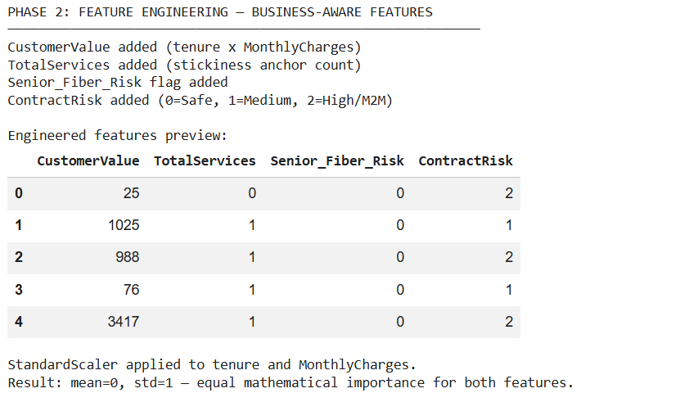
Figure 10 Feature Engineering and Business Aware Variables
These engineered features enhance the model’s ability to identify high-risk customers by combining multiple factors into meaningful indicators. Additionally, standardisation was applied to ensure equal importance of key numerical features. Overall, this step strengthens the model’s analytical capability and contributes to more accurate churn prediction.

Model Performance & Validation

ANN Model
The image illustrates the performance of the Artificial Neural Network (ANN) model across training iterations, comparing training accuracy and real-world (validation) accuracy. Initially, the model shows rapid learning, with training accuracy increasing sharply before stabilising around 75–76%, indicating that the model has effectively captured underlying patterns in the data.

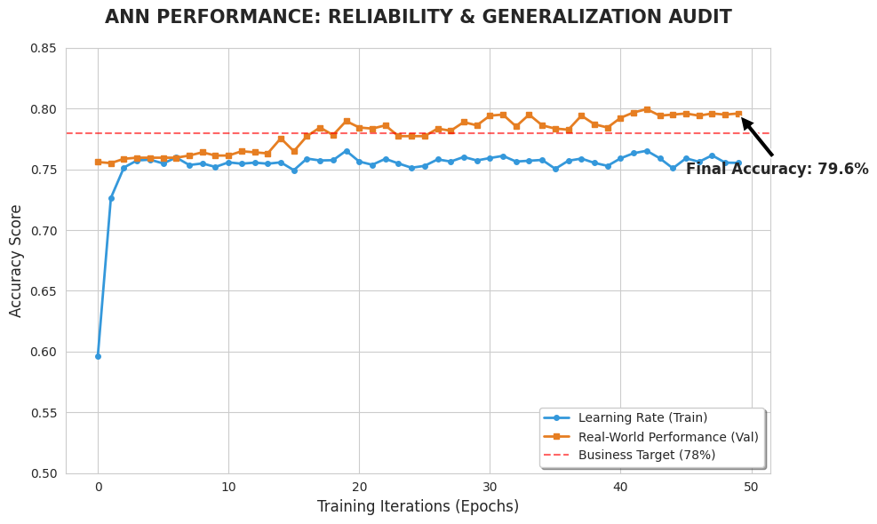
Figure 3 ANN Model

Meanwhile, the validation accuracy gradually improves and consistently remains slightly higher, reaching a final accuracy of approximately 79.6%, which exceeds the predefined business target of 78%. The close alignment between training and validation curves suggests that the model generalises well to unseen data without significant overfitting. Overall, the chart demonstrates that the ANN model is stable, reliable, and capable of accurately predicting customer churn in a real-world context.

Identification of Factors Contributing to Churn and Retention
Based on the ANN model’s weights and feature importance analysis, the following factors were identified as the primary drivers of customer movement:
Variable | Impact Type | Description
Contract Type | High Churn Factor | Month-to-month contracts are the strongest predictor of exit.
Internet Service | High Churn Factor | Fiber Optic users, particularly  seniors, show higher dissatisfaction rates.
Monthly Charges | High Churn Factor | Customers with higher monthly charges are more likely to churn, indicating price sensitivity and perceived low value.
Senior-Fiber Segment | High Churn Factor | This micro-segment shows disproportionately high churn, highlighting the combined effect of demographic and service-related dissatisfaction.
Tenure | Retention Factor | Longer tenure correlates with lower churn, peaking after the 12-month mark.

Top Predictive Drivers of Customer Churn
This image highlights the most influential variables driving customer churn based on their predictive power in the model. It shows that tenure is the strongest predictor, followed closely by MonthlyCharges, indicating that customers with shorter relationships and higher costs are more likely to churn.
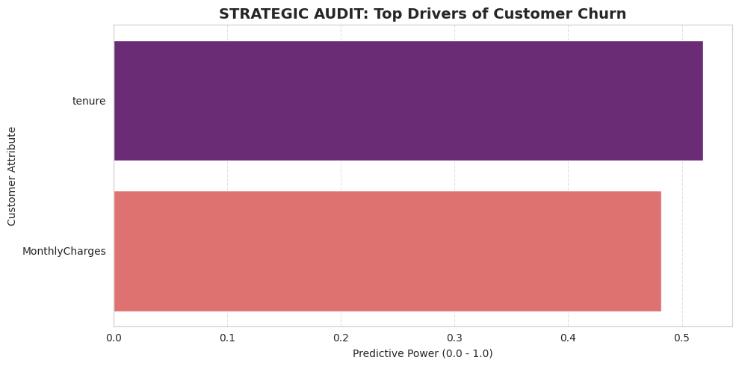
Figure 17 Top Predictive Drivers of Customer Churn
The chart quantifies the importance of these features, demonstrating how strongly they contribute to the ANN model’s predictions. Overall, it reinforces that customer duration and pricing are critical factors influencing churn behaviour and should be key focus areas for retention strategies.

Correlation Heatmap of Churn Drivers
This image displays a correlation heatmap illustrating the relationships between various customer features and churn behaviour. It highlights that factors such as ContractRisk, MonthlyCharges, and Senior_Fiber_Risk show stronger positive associations with churn, indicating that customers on high-risk contracts, higher charges, and specific segments are more likely to leave. Conversely, tenure and CustomerValue show negative correlations, suggesting that long-term and higher-value customers are more likely to stay.
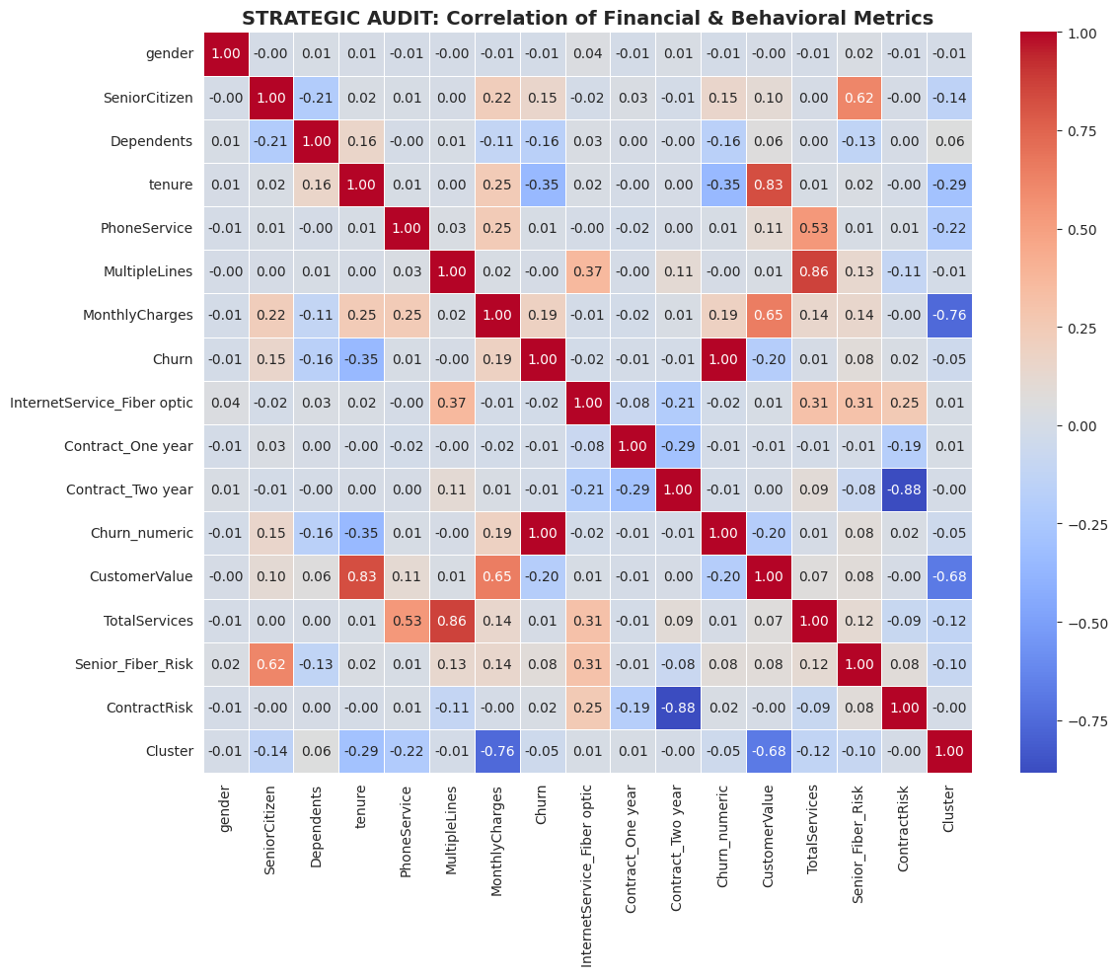
Figure 16 Correlation Heatmap of Churn Drivers
The heatmap also reveals how different variables interact with each other, helping identify key drivers of churn. Overall, this analysis supports the identification of critical factors influencing customer retention and revenue leakage.

Tenure vs Monthly Charges by Churn Status
This image visualises the relationship between customer tenure, monthly charges, and churn status. It shows that customers with low tenure (early months) and higher monthly charges are more likely to churn (orange points), while customers with longer tenure tend to stay (blue points).
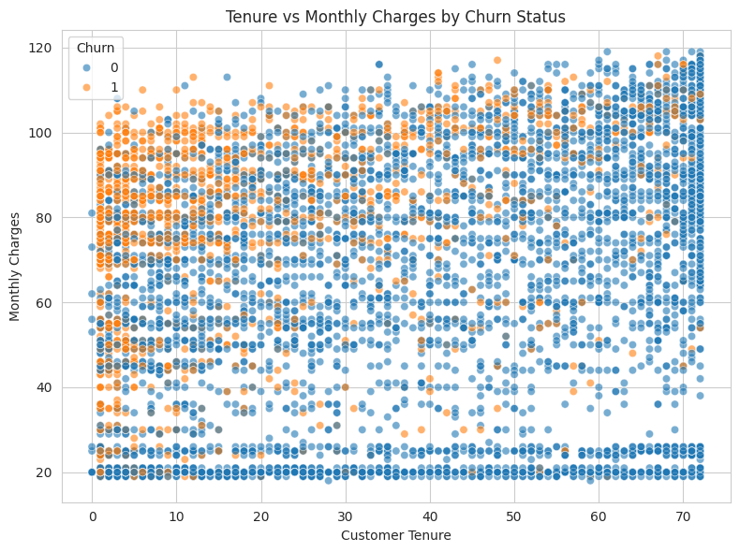
Figure 12 Tenure vs Monthly Charges by Churn Status
The pattern indicates that both pricing and customer lifecycle stage play a significant role in churn behaviour. Overall, the chart highlights that early-stage, high-cost customers are a key risk group, making tenure and monthly charges important factors driving churn.

AI Decision Logic for Churn & Revenue Leak Identification
This image illustrates how the model identifies churn risk using a decision-tree structure, highlighting the key variables influencing customer behaviour. The model primarily splits on tenure and MonthlyCharges, showing that customers with low tenure and certain pricing levels are more likely to churn.
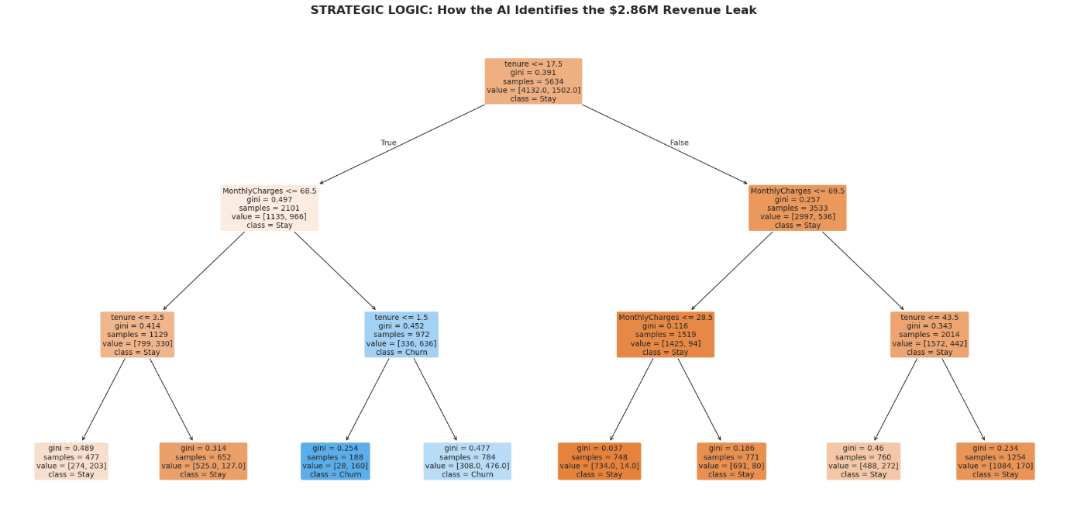
Figure 11 AI Decision Logic for Churn & Revenue Leak Identification
The branching structure demonstrates how different combinations of these factors lead to either churn or retention outcomes. This logic explains how the system detects high-risk segments contributing to the $2.86M revenue leakage. Overall, it clearly shows that tenure and pricing are the most critical factors driving churn decisions.

Senior-Fiber Churn Risk Comparison
This visualization compares churn probability between general customers and a specific high-risk group—senior customers using fiber internet. It shows that while average customers have a churn rate of around 25%, seniors on fiber plans experience a significantly higher churn rate of nearly 40%.
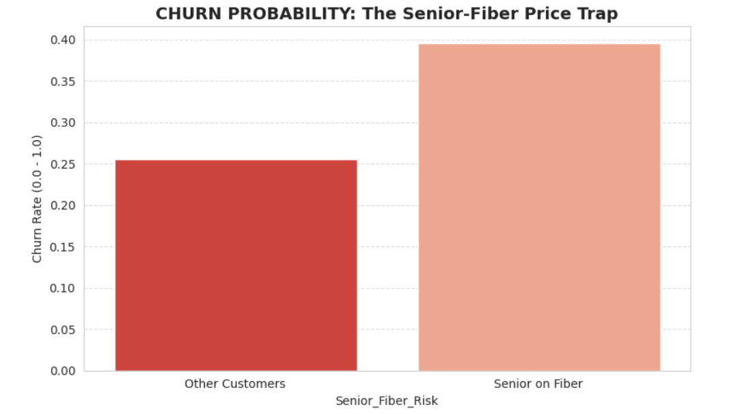
Figure 13 Churn Probability: The Senior-Fiber Price Trap
This indicates a strong relationship between age, service type, and customer dissatisfaction. The result suggests that senior users may face challenges such as high pricing, complexity of service, or lack of support, leading to increased churn. Overall, the chart highlights a critical high-risk segment that requires targeted intervention.

High-Risk Segment Comparison (Senior Fiber vs Others)
This image compares churn behaviour between the general customer base and a high-risk segment—senior customers using fiber services. It shows that the senior-fiber group has a significantly higher churn rate (39.63%) compared to other customers (25.58%), along with higher average monthly charges.

Figure 14 High-Risk Segment Comparison
Despite having a smaller population, this segment represents a disproportionately high churn risk. This indicates that the combination of higher pricing and specific customer characteristics contributes strongly to customer attrition, making it a key factor driving churn.

Senior-Fiber Micro-Segmentation Churn Analysis
This image highlights a micro-segmentation analysis comparing churn rates between the general customer population and a specific high-risk group—senior customers using fiber services. The chart shows that while the general population has a churn rate of 25.6%, the senior-fiber segment experiences a significantly higher churn rate of 39.6%.
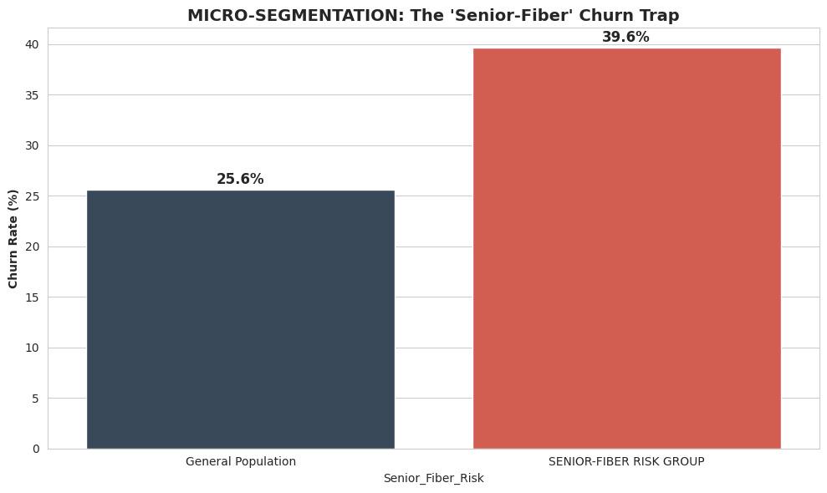
This sharp increase indicates that the combination of age and service type creates a strong risk factor for customer attrition. It suggests that senior users may face challenges such as higher pricing, service complexity, or lack of tailored support, making them more likely to leave. Overall, the image identifies a critical churn driver that requires focused intervention.

Recommendations for Targeted Retention Strategies
To mitigate the identified $2.86M revenue leakage, the following data-driven strategies are recommended:
The 8-Month Loyalty Trigger: Implement an automated outreach program at the 8-month mark to proactively address the 9.8-month onboarding cliff. This should include personalised incentives such as discounts, service upgrades, or loyalty rewards to strengthen early customer engagement and reduce churn during the most vulnerable lifecycle stage.
Senior-Fiber Specialized Support: Establish a dedicated concierge-style support service for senior customers using fiber internet. This service should focus on simplified onboarding, technical assistance, and personalised guidance to reduce service complexity, improve user experience, and increase perceived value.
Contract Migration Incentives: Offer targeted incentives for high-risk customers to transition from month-to-month contracts to longer-term agreements. Discounts, bundled services, or loyalty benefits can be used to increase commitment and reduce churn probability.
Dynamic Pricing & Value Optimisation: Introduce personalised pricing strategies for customers with high monthly charges who are at risk of churn. This may include tailored discounts, flexible payment plans, or bundled service offerings to improve perceived value and reduce price sensitivity.
Early Risk Detection & AI Alerts: Leverage the ANN model to continuously monitor customer behaviour and generate real-time churn risk alerts. This enables the organisation to take proactive retention actions before customers decide to leave.
Personalised Engagement Campaigns: Develop targeted marketing campaigns based on customer segmentation (e.g., At-Risk Newbies, Loyal High-Rollers). Personalised communication, offers, and recommendations can improve customer satisfaction and strengthen long-term relationships.
Enhanced Onboarding Experience:
Improve the initial customer onboarding process by providing guided setup, tutorials, and follow-up support during the first 3–6 months. A smoother onboarding experience can reduce early dissatisfaction and prevent churn.

Documentation of Limitations and Proposed Solutions

Limitation Encountered | Proposed Solution / Mitigation
Class Imbalance in Churn Data | Utilize SMOTE (Synthetic Minority Over-sampling Technique) or class-weighting methods to balance the dataset. This improves the model’s ability to correctly identify churn cases and reduces bias toward the majority (non-churn) class.
Static Nature of Dataset | Integrate real-time or streaming data pipelines to enable continuous model updates. This allows the ANN model to adapt to changing customer behaviour and seasonal trends, improving long-term accuracy.
External Market Factors Not Included | Incorporate external variables such as competitor pricing, service availability, and regional infrastructure conditions to provide a more holistic and realistic prediction model.
Limited Feature Scope | Expand the dataset to include additional features such as payment methods, customer support interactions, service usage patterns, and customer satisfaction scores to improve predictive depth.
Model Simplicity (Basic ANN Architecture) | Enhance the ANN model by tuning hyperparameters, increasing hidden layers, and applying cross-validation techniques to improve predictive performance and robustness.
Lack of Behavioural / Real-Time Signals | Implement behavioural tracking (e.g., usage frequency, complaints, login activity) to capture early warning signs of churn and improve prediction accuracy.

Data Preparation & Encoding Summary
This image shows the data preparation phase, confirming that there are no missing values across all variables and that encoding has been successfully completed, resulting in a final dataset of 7,043 records and 11 features. While this indicates a clean and well-prepared dataset, it also highlights a limitation—real-world data is rarely perfect.

Figure 18 Data Preparation and Encoding
The absence of missing values suggests the dataset may not fully capture real-world complexities, potentially reducing the model’s ability to generalise. This reinforces the need for future improvements such as incorporating more diverse data sources and handling real-world data inconsistencies.

